Diffusion model test

Preface on Norms:

When we are dealing with numbers we can identify them as being large or small. Arrays and vectors are function of many elements but we need to measure their size -an index for them to be small or large.

If we can find constants p ≥ 1 and c > 1 such that
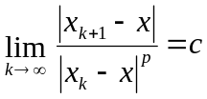 (1)
we say that convergence is of order p. If p=1 convergence is linear and the rate of convergence is c, in which c must be smaller than 1.
In solution procedures using vectors and matrices we also need a measure of convergence. Realizing that the size of a vector or matrix should depend on the magnitude of all elements in the arrays, we arrive at the definition of vector and matrix norms. By definition, a norm is a single number that depends on the magnitude of all elements in the vector or matrix. A norm should satisfy the following conditions:
1- 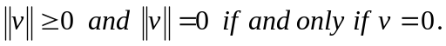 (2)
2- 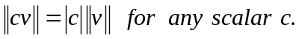 (3)
3- 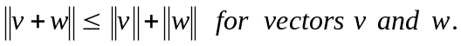 (4)

The relation 3 is triangle inequality. The following three vector norms are commonly used and called the infinity, one and two vector norms:

1- 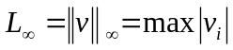 (5)

2- 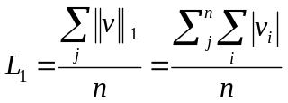 (6)

3- 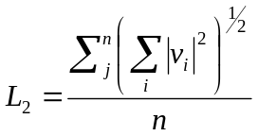 (7)

In our case we can define v as the error between U_{exact} and U_{numerical} at each point.

Test cases:

The explicit forms of finite-volume schemes must satisfy the following stability criteria for dispersion:
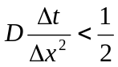 (8)
The implicit forms of the finite-volume schemes, however, are stable for all Δx and Δt and, therefore, do not need to satisfy the above stability criteria.

Two different problems were devised to test the diffusion model. In order to satisfy dispersion stability criteria for all explicit models, the temporal step size was always chosen to satisfy the dispersion stability criteria, for the particular Δx, u and D combination that was being tested.

Convergence test for Neumann _ Dirichlet Boundary Condition
Convergence tests were performed for a case taken from Fletcher (1991), which uses a Neumann boundary condition that varies in time. In this particular case, advection and reactions are not present, meaning that only the pure dispersion term is needed from the A-D-R equation. Recalling the dispersion equation from before:

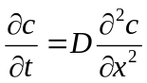 (9)

will be solved in the spatial interval 0.1 ≤ x ≤ 1 using the following Neumann boundary condition at x = 0.1:

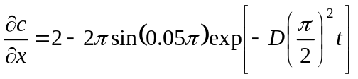 (10)
and a Dirichlet boundary condition of C = 2 @ X = 1. The dispersion models were tested for two incremental spatial spans between 3 to 192 and 25 to 3200 (number of volumes), inclusive, using a dispersivity of D = 1 and time spans and theta which guarantees stability. The results were compared against the following analytical solution to find the error. Then the three norms of error where calculated to perform test convergence and accuracy order tests

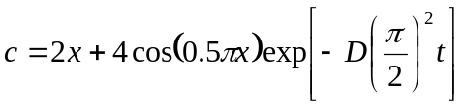 (11)

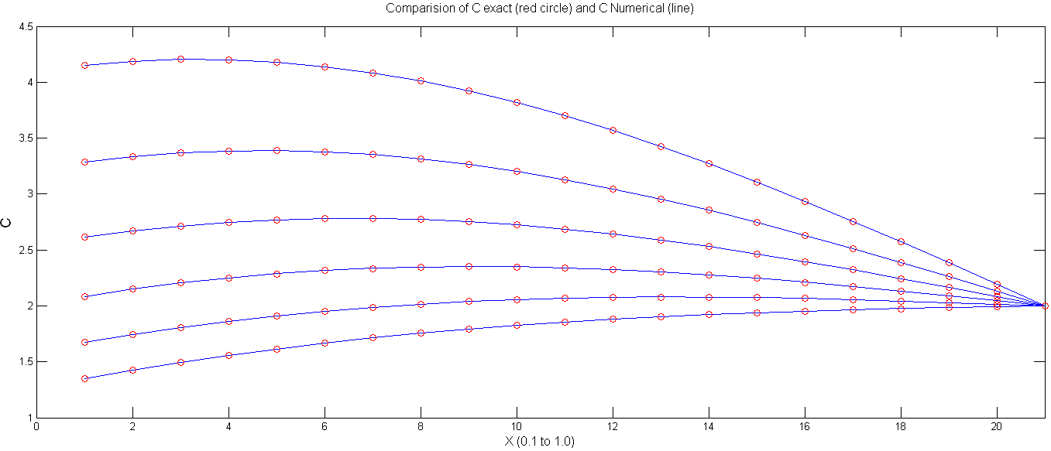
Figure 1: Comparison of numerical and exact solution for the case test case one (number of volumes =21)

Figure 1 shows the agreement of exact and numerical solution for this case. Tables 1 and 2 show the error convergence and accuracy tests for this case (N_D). As expected, the rate of error convergence after reaching appropriate number of volumes tends to 4 ( 2nd order of accuracy).

`Table 1: Errors and Norm of Errors in Different Mesh Sizes for Θ=0.5
Num of volumes | L1 | Rate of L1 change |  | L2 |  | Rate of L2 change |  | L∞ |  | Rate of L∞ change |  | Ddt/dx² |  | Stability
25 | 2.030E-03 | 1.094E+00 |  | 8.407E-07 |  | 5.355E+00 |  | 3.622E-04 |  | 3.844E+00 |  | 3.858E-01 |  | O.K
50 | 1.855E-03 | 1.025E+00 |  | 1.570E-07 |  | 5.797E+00 |  | 9.422E-05 |  | 4.090E+00 |  | 1.482E+00 |  | O.K
100 | 1.809E-03 | 1.006E+00 |  | 2.708E-08 |  | 5.760E+00 |  | 2.304E-05 |  | 4.072E+00 |  | 6.050E+00 |  | O.K
200 | 1.798E-03 | 1.001E+00 |  | 4.701E-09 |  | 5.845E+00 |  | 5.657E-06 |  | 4.151E+00 |  | 2.445E+01 |  | O.K
400 | 1.796E-03 | 1.000E+00 |  | 8.044E-10 |  | 6.301E+00 |  | 1.363E-06 |  | 4.611E+00 |  | 9.827E+01 |  | O.K
800 | 1.795E-03 | 1.993E+00 |  | 1.277E-10 |  | 6.708E+00 |  | 2.956E-07 |  | 3.385E+00 |  | 3.941E+02 |  | O.K
1600 | 9.008E-04 | 1.002E+00 |  | 1.903E-11 |  | 1.518E+00 |  | 8.732E-08 |  | 1.000E+00 |  | 1.578E+03 |  | O.K
3200 | 8.991E-04 | X |  | 1.254E-11 |  | X |  | 8.732E-08 |  | X |  | 6.317E+03 |  | O.K
Table 2: Errors and Norm of Errors in Different Mesh Sizes for Θ=0.5
Num of volumes | L1 | Rate of L1 change |  | L2 |  | Rate of L2 change |  | L∞ |  | Rate of L∞ change |  | Ddt/dx² |  | Stability
3 | 1.701E-02 | 2.895E+00 |  | 2.478E-04 |  | 8.544E+00 |  | 7.588E-01 |  | 1.204E+02 |  | 5.556E-03 |  | O.K.
6 | 5.878E-03 | 2.084E+00 |  | 2.900E-05 |  | 5.561E+00 |  | 6.300E-03 |  | 4.006E+00 |  | 2.222E-02 |  | O.K.
12 | 2.820E-03 | 1.376E+00 |  | 5.216E-06 |  | 5.604E+00 |  | 1.573E-03 |  | 4.002E+00 |  | 8.889E-02 |  | O.K.
24 | 2.050E-03 | 1.104E+00 |  | 9.307E-07 |  | 5.631E+00 |  | 3.930E-04 |  | 4.002E+00 |  | 3.556E-01 |  | O.K.
48 | 1.858E-03 | 1.026E+00 |  | 1.653E-07 |  | 5.651E+00 |  | 9.819E-05 |  | 4.007E+00 |  | 1.422E+00 |  | O.K.
96 | 1.810E-03 | 2.249E+00 |  | 2.925E-08 |  | 5.685E+00 |  | 2.450E-05 |  | 4.029E+00 |  | 5.689E+00 |  | O.K.
192 | 8.048E-04 | X |  | 5.145E-09 |  | X |  | 6.082E-06 |  | X |  | 2.276E+01 |  | O.K.

Convergence test for Neumann _ Dirichlet Boundary Condition
The models were also tested using the Dirac delta function centered at x = 0 as the initial condition. Informally, the Dirac delta function can be described as a function that is zero everywhere but at the origin, where it is infinite. This condition is explained by Equation (12); however, it must also satisfy the identity in Equation (13).

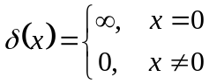 (12)

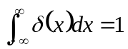 (13)
Applying the dispersion equation to the Dirac delta function results in the following Gaussian function,

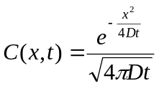 (14)
Where D is Dispersion coefficient (D=2)
Convergence tests were performed on the models using the following initial condition to represent the Dirac delta function described by Equations 12 and 13.

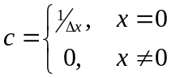 (14)

Convergence testing was performed on the case two dispersion models for the same time span of t = 4 sec, using a dispersivity of D = 2 and spatial step sizes of 2⁻¹, 2⁻², 2⁻³and 2⁻⁴. Dirichlet boundary conditions of C = 0 were used at spatial locations of x = ±100 because the theoretical concentration values at those places never rises above 10⁻⁸ during the course of the modeling period

Table 3: Errors and Norm of Errors in Different Mesh Sizes for Θ=0.5
Num of volumes | L1 | Rate of L1 change | L2 | Rate of L2 change | L∞ | Rate of L∞ change | Ddt/dx² | Stability
100 | 1.624E-02 | 1.773E+01 | 7.852E-06 | 2.473E+00 | 1.580E-03 | 2.944E+00 | 1.000E-01 | O.K
200 | 9.157E-04 | 2.600E+00 | 3.175E-06 | 3.485E+00 | 5.366E-04 | 3.816E+00 | 2.500E-02 | O.K
400 | 3.522E-04 | 2.759E+00 | 9.111E-07 | 2.222E+00 | 1.406E-04 | 3.979E+00 | 6.250E-03 | O.K
800 | 1.277E-04 | X | 4.099E-07 | X | 3.534E-05 | X | 1.563E-03 | O.K

In the figure 2 numerical solution of case 2 (D_D) and its analytical solution are supper imposed on each other.
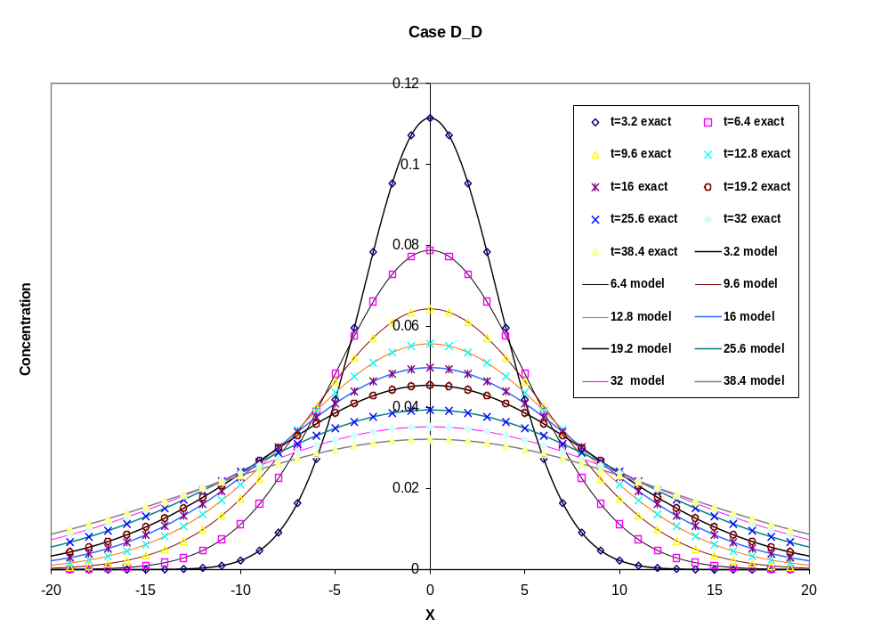
Figure 2: Exact and Numerical Solutions for Dirichlet_Dirichlet Test Case

